
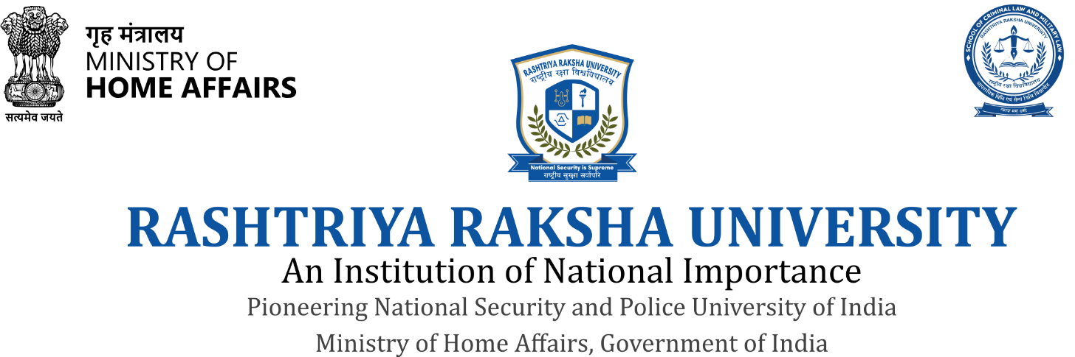

School of Criminal Law and Military Law (SCLML)
National Resource Centre on Anti-Human Trafficking (NRCHT)

Organizes
Three Days Workshop on

Anti-Human Trafficking

Program for the Gujarat Police Officers serving under AHTU in the observance of International Day for Awareness Against Human Trafficking to be organized from
(20th-22nd August 2026)

(Mode of Training: Physical)

THE UNIVERSITY
The Rashtriya Raksha University is an Institution of National Importance, established by the Ministry of Home Affairs, Government of India. The University aims to provide comprehensive education, research, training and extension in all aspects of national security and policing and retired personnel from military and paramilitary forces, security and intelligence agencies, police establishments and civilian student communities. The University’s Central Campus is located in Lavad- Dehgam, District- Gandhinagar, State-Gujarat (India). The University aims to ensure fifty percent of practical knowledge and training in each of the academic programs. Thus, experience, specialization and commitment to serve the cause of national security and police is essential to build the strong foundation of the University. The University conducts academic, research and training programs through its various specific schools in which School of Criminal Law and Military Law is one of them.

SCHOOL OF CRIMINAL LAW AND MILITARY LAW (SCLML)
The School of Criminal Law and Military Law, is a well-established school of RRU offering LLM in Criminal & Security Laws, MA/MSc in Criminology & Crime Sciences at Masters Level, BBALLB at Integrated Bachelor level, Diplomas, PhD and training course for Indians and foreign nationals. The school of Criminal Law and Military Law has developed interdisciplinary and multidisciplinary courses based on the scientist-research model is aspiring to provide excellence education and training to the students to prepare future working professionals contributing to prevention of crimes, justice, carry out intervention and provide their services to crime victims and rehabilitation of the offenders. Their knowledge and skill would aid in addressing the internal security issues for preventing crime and criminality and ensure social & communal harmony in the society for the wellbeing of all.

THE NATIONAL RESOURCE CENTRE ON ANTI-HUMAN TRAFFICKING (NRCHT)
The National Resource Centre on Anti-Human Trafficking (NRCHT) was established on 26th February, 2021. The Resource Centre on Anti-Human Trafficking has been established by signing of a Memorandum of Understanding (MoU) between Indian Police Foundation (IPF) and RRU, an important chapter in the history of anti-human trafficking in India and the world. A world’s first resource Centre on all matters relating to human trafficking and response on human trafficking including prevention and combating trafficking. The Centre is a repository of all resources including books, articles, pictures, videos, media reports, films both in hard copy and electronic format. The Centre aims to facilitate and organize seminars, webinars, conferences or workshops on human trafficking under 3P Model that is P=Prevention (at the source, transit, and destination, including in the electronic space), P=Protection (including post rescue care, counselling,

repatriation, rehabilitation, reintegration, etc.) and P=Prosecution (including crime registration, investigation, justice delivery etc.).

ABOUT THE COURSE
The Workshop in ‘Anti Human Trafficking’ has been started with the view of that the trainee to understand the various forms of human trafficking in a broader way as an Organized Crime and get trained the professional methods, techniques for tackling in practical or policy recommendation. The modules in the course are comprehensive in nature to help the trainee know multiple dimensions associated with human trafficking.
The Workshop on Anti Human Trafficking is a short-term training cum awareness program based on expert lectures on different course modules.
Objectives of the Workshop
- To bring about comprehensive understanding of human trafficking
- To create the pool of expert and professional with the security education, practical knowledge for policy, rehabilitation and preventions of human trafficking
- To provide the extension services for those who are working in the government agencies in human trafficking through certification.

STRUCTURE OF THE COURSE

Day | Course Module | Duration
1 | Concept of Human Trafficking (Sex Trafficking) | 120 Minutes
2 | Cross Border Human Trafficking in North East States of India | 120 Minutes
3 | Compensation to the Victim of Human Trafficking: Legal and Social | 120 Minutes
4 | Labour Trafficking | 120 Minutes
5 | Forensic Investigation in Drug and Human Trafficking Cases | 120 Minutes
6 | Case Study | 120 Minutes

Total hours for successful completion of the Course: 3 days.

Eligibility Criteria for the Admission: Open to All

The University aims to provide comprehensive education, research, training and extension in all aspects of national security and policing and retired personnel from military and paramilitary forces, security and intelligence agencies, police establishments and civilian student communities. For which, the course contents of the training workshop is designed for law enforcement officers engaged and interested in human trafficking crime prevention and other enforcement agency’s nominated person for their career perspectives.
Program Coordinator: : Dr. Shahanshah Gulpham
Mobile: +91 8130638598 | Email: shahanshah.gulpham@rru.ac.in

SCOPE OF THE COURSE
The course has been intended to meet the developing the needs of specialists in the field of human trafficking including transnational organized crime.

RESOURCES AVAILABLE
The School of Criminal Law and Military Law (SCLML) will provide all necessary requirements in smooth conducting of the above programme.

